TC-VER-011
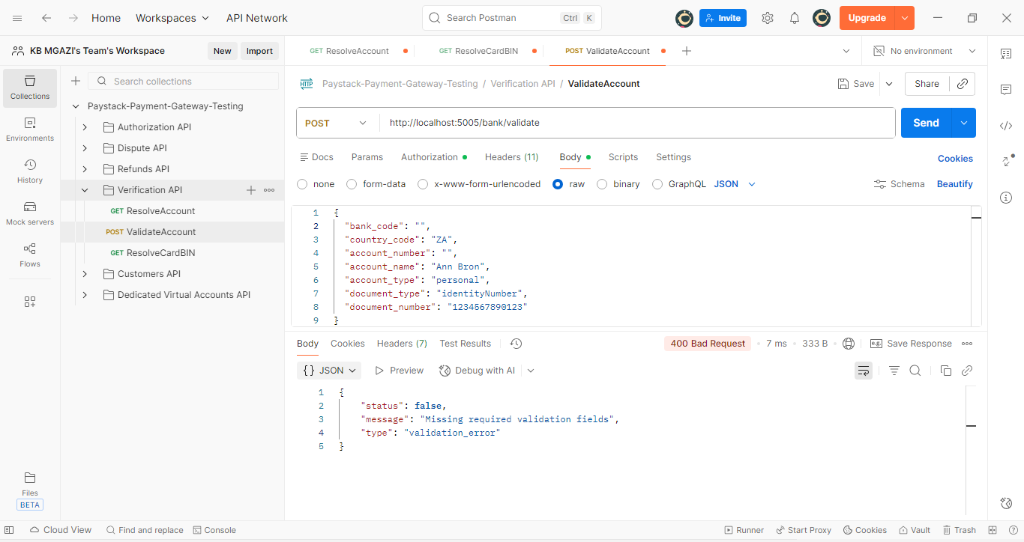
Request:
{
"bank_code": "",
"country_code": "ZA",
"account_number": "",
"account_name": "Ann Bron",
"account_type": "personal",
"document_type": "identityNumber",
"document_number": "1234567890123"
}

Response:
{
"status": false,
"message": "Missing required validation fields",
"type": "validation_error"
}

